Use Business Events with Power Automate flows
- Navigate to https://make.powerautomate.com/ and select Automate cloud flow option to create new flow.
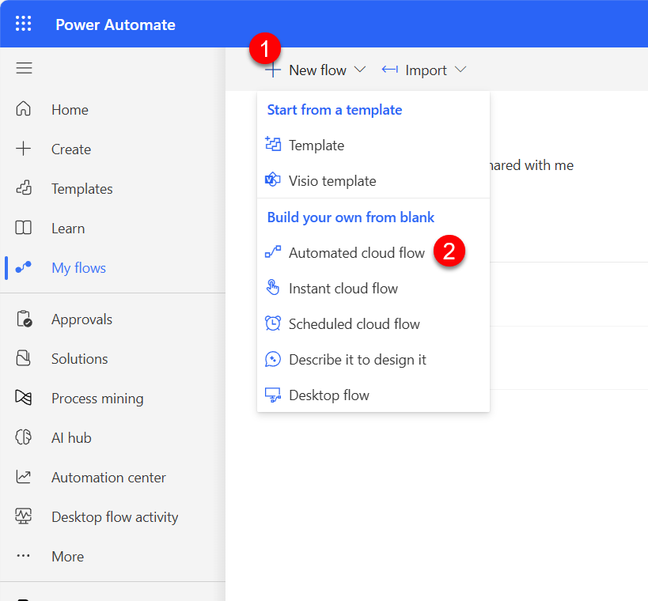
- Select Skip.
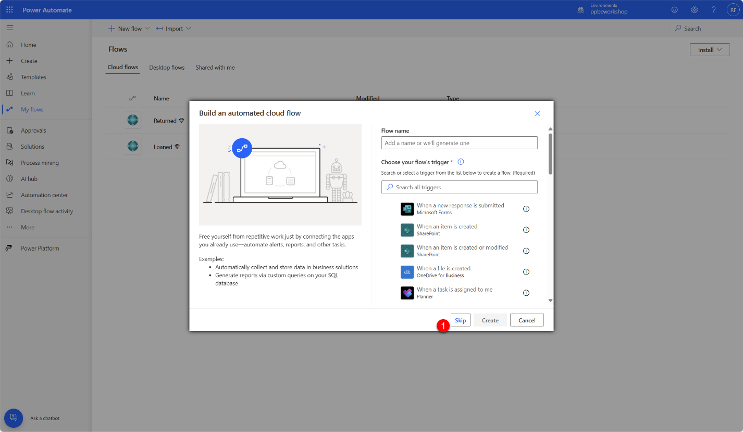
- In the list of triggers select When a business event occurs (V3) trigger.
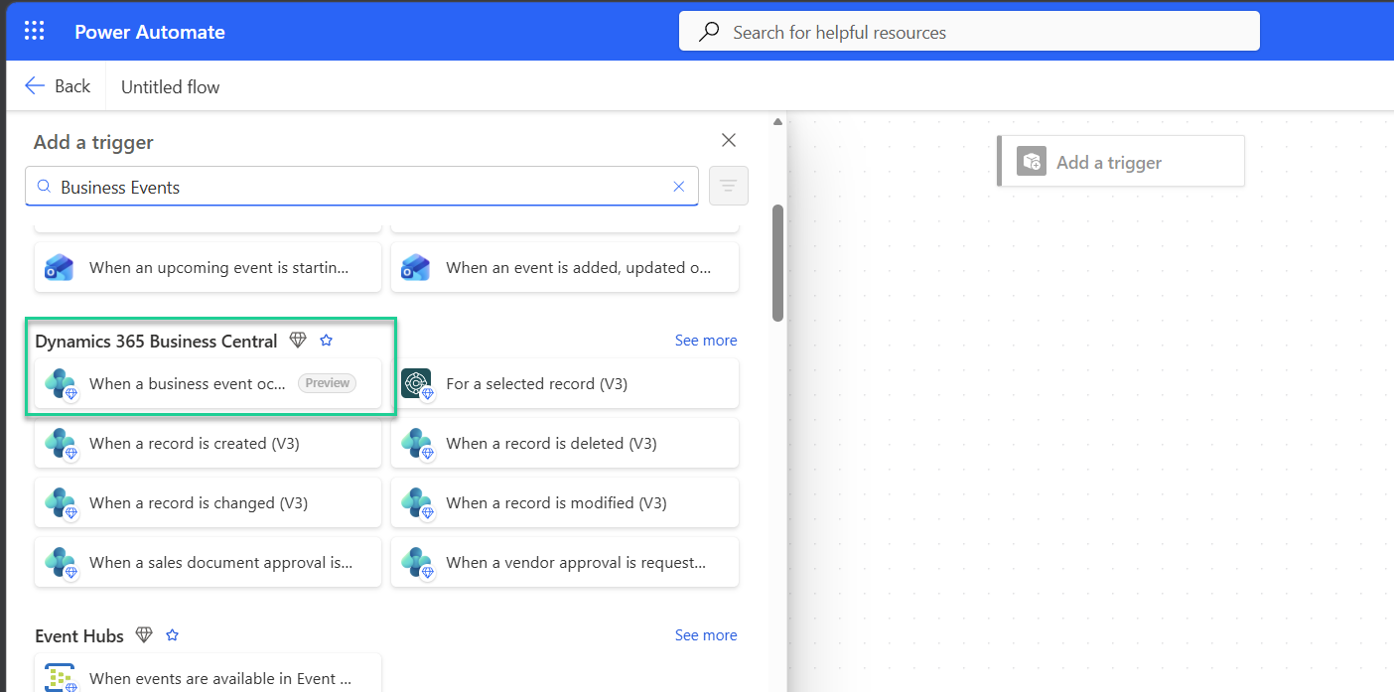
- In the trigger option, select environment and choose correct Business Event from the business event catalogue
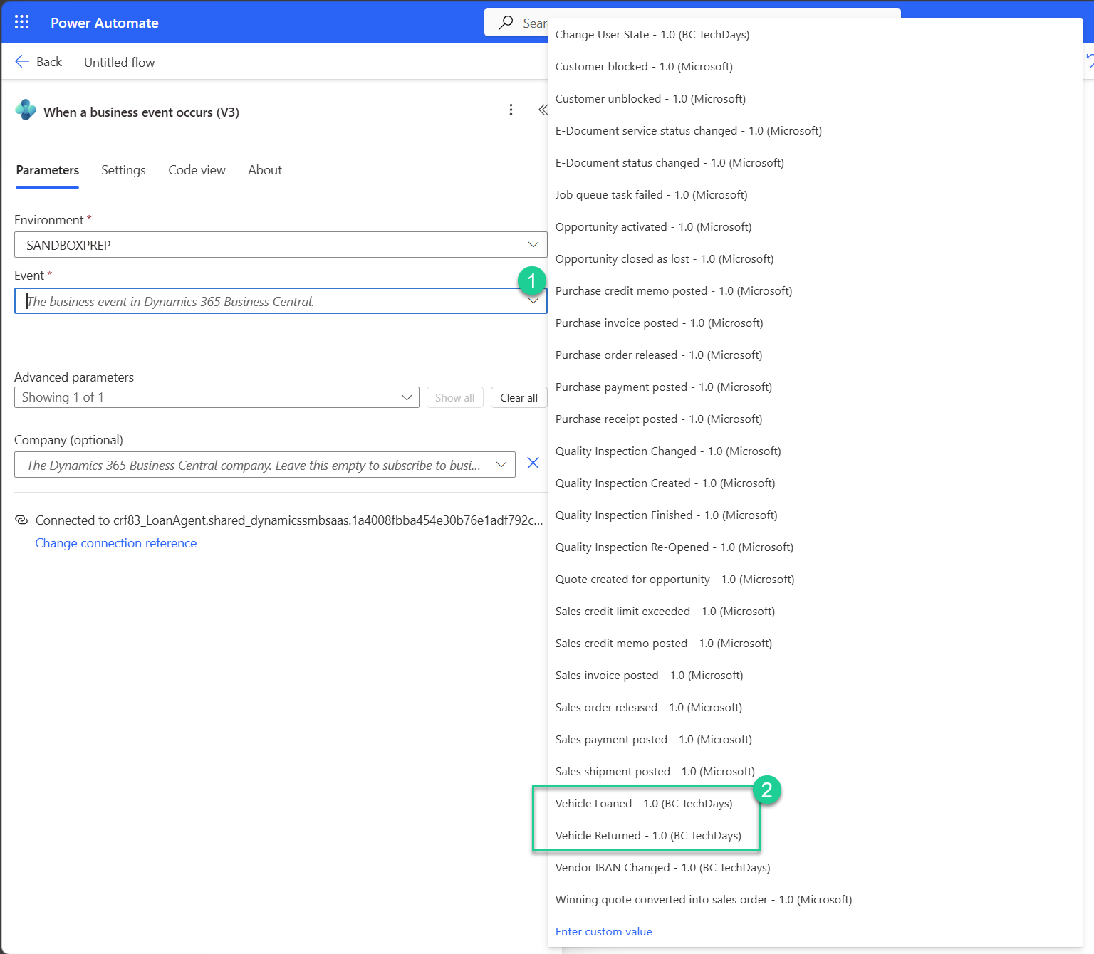
- In the list of action select Send an email (V2) action. Compose your email by using fields from the trigger.
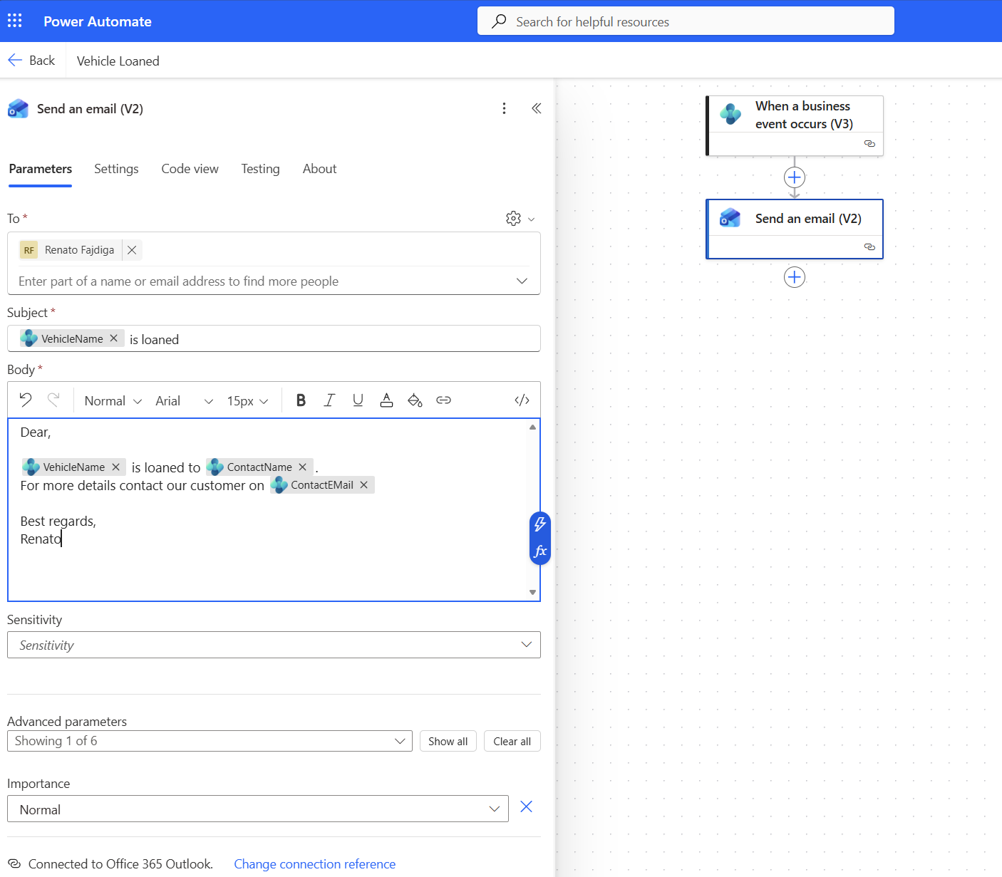
- Create new Loan order and select Loan action. Check your email.
